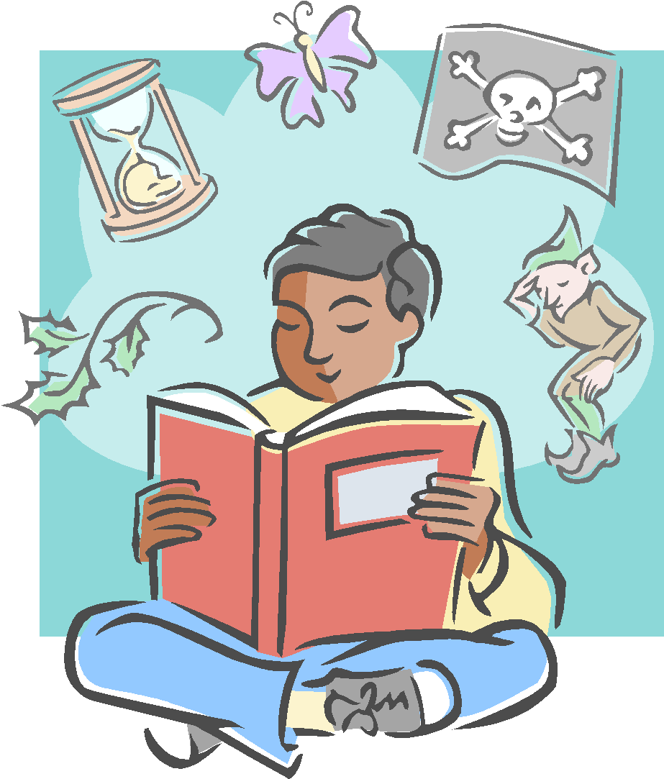
Can recite some simple poems by heart – these can be nursery rhymes and songs too.

Make sure they have access to nursery rhymes, poems and songs (in English and native language) – there are some lovely playlists on YouTube too that have actions to them.
It’s fine that they want to return to the same, safe texts. If you can, re-enact some of the stories with puppets or cut-outs to help develop language.
Sign up to the local library. You can get out x20 books with their book card. Are not charged for lateness or loss of books.
Plenty of reading aloud experiences with the child in charge of choosing the books at times.
Recognises and joins in with predictable phrases and can retell familiar stories.
Begins to understand the difference between fiction and non-fiction
FOUNDATION
Helping your child get better at reading is important to all of us. Whenever you read with your child, asking them one or two of these questions will improve their comprehension. Writing down what they say would help us too! E.g. Jenny said that her favourite part of the story was when Max hid up in the tree because it was exciting.

Explore and enjoy new words and explain their meanings.
Point to objects in picture books to ensure that children understand what these mean.

When reading a new book, you might want to draw attention to the title, the author and illustrator and explain who these are and predict what the book might be about.

Your child can tell you what books they prefer and might tell you aspects that they either like or dislike.

When they have had a story read to them or have finished reading a story, your child is able to recall and retell it with some support.
Make sure that your child has access to books that support their interests and needs.

With some of the books that they are reading and exploring, see if you can find opportunities to relate the events to their own experiences or similar texts/films.
Your child might start to be confident in talking about their reading preferences and what they have enjoyed or not enjoyed.
YEAR 1

Explore and enjoy new words and explain their meanings.
Your child is beginning to use key words associated with books such as ‘cover’, ‘author’, ‘illustrator’, ‘blurb’, ‘contents’

When reading something new, your child can make a prediction on what might happen.
They can begin to discuss why they think a character did what they did.

Provide your child with access to a wide range of stories, poems and information texts if you can. Model how to browse when looking at books and explain to your child this process.
Model your own reading for pleasure – this doesn’t have to be on a book at all.
Helping your child get better at reading is important to all of us. Whenever you read with your child, asking them one or two of these questions will improve their comprehension. Writing down what they say would help too. E.g. Jenny said that her favourite part of the story was when Max hid up in the tree because it was exciting.
Reading for Pleasure is paramount.

They have begun to explore selections of work by particular authors and can choose favourites within those bodies of work.

They might be able to tell you what happened before or after an event.
They can talk about what they think about different characters

When they have had a story read to them or have finished reading a story, your child is able to recall and retell it with some support.
With some of the books that they are reading and exploring, see if you can find opportunities to relate the events to their own experiences or similar texts/films.
Now that your child is clear about their reading preferences, see if you can give them access to a wider range of texts to broaden their reading experiences
Provide your child with access to a wide range of stories, poems and information texts if you can. Model how to browse when looking at books and explain to your child this process.
Model your own reading for pleasure – this doesn’t have to be on a book at all.
YEAR 2

Explore and enjoy new words and explain their meanings.
They can give a reason that explains the actions of a character (why they did something) or what kind of person they are

They can say when I think a book is set and explain how I worked it out.
With support, they can find and talk about the words the author has used and how they are good choices.

Helping your child get better at reading is important to all of us. Whenever you read with your child, asking them one or two of these questions will improve their comprehension. Writing down what they say would help too! E.g. Jenny said that her favourite part of the story was when Biff hid up in the tree because it was exciting.
Reading for Pleasure is paramount.

Explores a range of non-fiction books and can now define the different parts: title, glossary, index, contents, heading

When reading, they self-correct when something does not make sense and use appropriate intonation when reading aloud.

They enjoy exploring a range of text types including: non-fiction, comics, graphic novels, short novels, picture books, myths, legends and poetry.
With some of the books that they are reading and exploring, see if you can find opportunities to relate the events to their own experiences or similar texts/films.
Now that your child is clear about their reading preferences, see if you can give them access to a wider range of texts to broaden their reading experiences
Your child might be choosing to read independently at home. Again, research states that modelling this yourself can help.
Continue to ensure that they have time to choose what they want to read. Consider their interests and preferences.
YEAR 3

When answering questions about the text, they can explain why some characters said or did something and argue why they think a character might be feeling a certain way.

They can say when I think a book is set and explain how I worked it out.
With support, they can find and talk about the words the author has used and why they interest them. New words are looked up in a dictionary

Helping your child get better at reading is important to all of us. Whenever you read with your child, asking them one or two of these questions will improve their comprehension. Writing down what they say would help too! E.g. Jenny said that her favourite part of the story was when Biff hid up in the tree because it was exciting.
Reading for Pleasure is paramount.

Explores a range of non-fiction books, can define the different parts: title, glossary, index, contents, heading and discuss layout

From reading a character’s feelings, thoughts or actions, they can justify what kind of person they are.
They enjoy exploring a range of text types including: non-fiction, comics, graphic novels, short novels, picture books, myths, legends and poetry.
Your child is beginning to develop stamina when reading and is starting to cope with more demanding texts. They may be moving into silent reading.
When you ask them about reading preferences, they can tell you the types of stories/texts that they like and explain what it is about them that is appealing.
Reading accurately at speed with appropriate intonation and re reads passage to ensure understanding.

They are beginning to re-read a variety of texts around known authors whilst beginning to choose from a wide range of book including new authors.

YEAR 4
They can explain why characters feel and act the way they do and use clues from the way characters speak and act to help them justify their reasons behind their actions.
Your child is making comments on the author’s choice of words.

They can say when I think a book is set and explain how I worked it out.
They can find and talk about the words or phrases the author has used and why they interest them. New words are looked up in a dictionary

Helping your child get better at reading is important to all of us. Whenever you read with your child, asking them one or two of these questions will improve their comprehension. Writing down what they say would help too! E.g. Jenny said that her favourite part of the story was when Biff hid up in the tree because it was exciting.
Reading for Pleasure is paramount.

They are reading books with a small amount of challenging vocabulary which might encourage them to use a dictionary

#
From reading a character’s feelings, thoughts or actions, they can justify what kind of person they are.
They enjoy exploring a range of text types including: non-fiction, comics, graphic novels, short novels, picture books, myths, legends and poetry.
YEAR 5

They can describe, using examples in the text, how the author has chosen vocabulary to create various effects (creepy, descriptive, cold, attentive, curious).
They are beginning to a choose a wider range of texts when reading including authors that they may not have previously chosen.
Your child is comfortable with reading both silently and aloud.
When reading, they can make connections with other stories.

They can find and talk about the words or phrases the author has used and why they interest them. New words are looked up in a dictionary with confidence

Helping your child get better at reading is important to all of us. Whenever you read with your child, asking them one or two of these questions will improve their comprehension. Writing down what they say would help too! E.g. Jenny said that her favourite part of the story was when Biff hid up in the tree because it was exciting.
Reading for Pleasure is paramount.

When exploring non-fiction texts, in whatever form, they can locate, retrieve and draw out information with confidence. They are beginning to read several books on the same subject and draw information together. E.g. When studying volcanoes or famous women in science

I can begin to talk about the themes in the novels that I am reading and what message the other might be trying to share with me about people.

From reading a character’s feelings, thoughts or actions, they can justify what kind of person they are.
They enjoy exploring a range of text types and often enjoy reading challenging texts that are not ones that I would usually pick up.
They are showing a greater interest in book awards (like the UKLA or Yoto Carnegie), reading the synopsis of the books in the shortlist and deciding which ones I might like to read. I can explain my choices to someone.
YEAR 6

When discussing the writing in a book, they might compare how style and word choice is different to other texts. When doing so, they might explain how this is and why this might be.

Your child can examine how characters change throughout a text. They can explain their thinking by calling on actions and thoughts that the character has.

When exploring non-fiction texts, in whatever form, they can locate, retrieve and draw out information with confidence. They are beginning to read several books on the same subject and draw information together. E.g. When studying volcanoes or famous women in science
They are becoming more critical of their reading and talk about their choices of author and theme. They may start reading children’s classics
When they are reading, your child can compare characters both within the text and say how they are similar and different and do this across different texts too.
Helping your child get better at reading is important to all of us. Whenever you read with your child, asking them one or two of these questions will improve their comprehension. Writing down what they say would help too. E.g. Jenny said that her favourite part of the story was when Biff hid up in the tree because it was exciting.
Reading for Pleasure is paramount.

