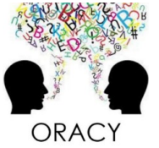
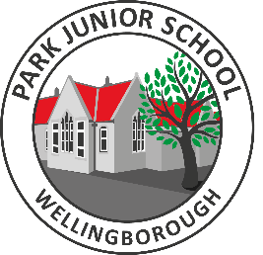
Questions to ask when reading with a child

Reviewing
Can you tell me what your book is about?
Where is your story set, how do you know?
What characters have you been introduced to so far?
What are the characters like?
Do the different characters all get on?
When they are reading
What does that word mean? How do you know it means that?
How can you use the rest of the sentence/the next sentence to help you work out the meaning of that word?
What words on this page impress or confuse you?
Can you summarise what you have read so far?
If you were to meet the main character, what would you ask them?
Predicting
What do you think will happen to the main character?
Why do you think this will happen?
Are there any clues to tell you what will happen next?
Do you think the story will stay in this setting?
Can you find any evidence in the story that shows…?



