Pilgrimage – Knowledge Organiser Year 6 Summer 1
Pilgrimage | A journey, especially a long one, made to a sacred place as an act of religious devotion. | Christianity | Hinduism
Pilgrimage |  | Pilgrimages:  - First made to sites connected with the birth, life, crucifixion and resurrection of Jesus.  - Now made to Rome and other sites associated with the apostles, saints and Christian martyrs, as well as to places where there have been apparitions of the Virgin Mary.  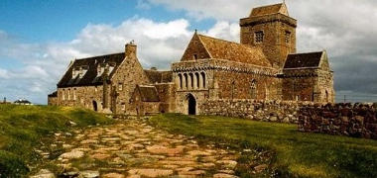  Iona in Scotland  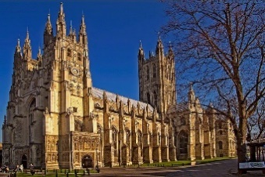  Canterbury Cathedral | Pilgrimage:  - The most famous Hindu pilgrimage is the Khumbh Mela, which takes place on the River Ganges in India.  - This is thought to be the biggest religious gathering.  Khumbh Mela  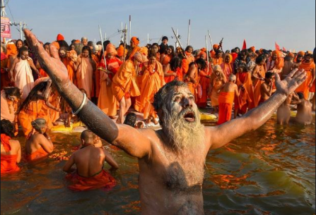  The River Ganges  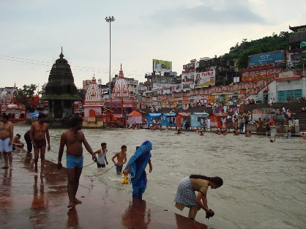
Pilgrim | A person who undertakes a pilgrimage.
Although people go on pilgrimages for different reasons, religious pilgrimages have the following things in common:

- Making the plans’
- Saving for the trip.
- Undertaking the trip.
- The journey and the arrival at the sacred place.
- To say sorry to their god.
- Undertaking a pilgrimage is part of their religious teaching.
- Because they may be ill or wish to be healed.
- To gain a feeling of closeness to their god.
Judaism |  | Islam
Pilgrimage:  - The Wailing Wall in Jerusalem, Israel is a place of pilgrimage for Jews from around the world.  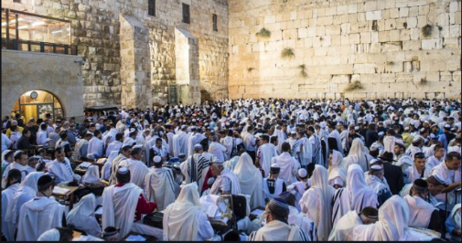  The Wailing Wall  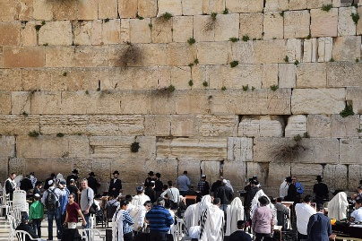 |  | Pilgrimage:  - The Hajj is a religious journey to Makkah (Mecca) that all Muslims try to make at least once in their life.  - The Hajj is one of the Five Pillars of Islam.  

