Year 6 Knowledge Organiser Summer One What does it mean to be a Sikh in Britain today?
VOCABULARY |  | 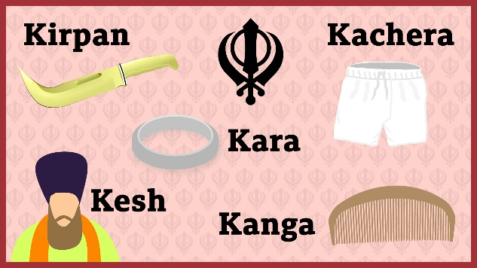  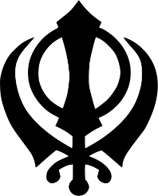  The Khanda  Guru Nanak taught:  - There is only one God. Guru Nanak taught that God is ‘neither a man nor a woman’. Sikhs usually use the name Waheguru for God.  - Different religions are different paths to the same one God  - Work hard and earn an honest living  - Lead a good life and help others  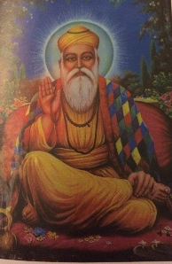  - We are all equal. Men and women have the same rights/responsibilities  - Always speak the truth.  Guru Nanak
Emblem | An image to represent a concept or identity. The ‘Khanda’ is the emblem of the Sikh community.
Sikh | Someone who follows the religion of Sikhism
Guru | A wise teacher
Guru Nanak | The founder of Sikhism
Khalsa | People who have been confirmed as full members of the Sikh religion and who wear the 5 Ks. The name Khalsa means ‘the pure ones’. The Khalsa was created in 1699 but Sikhism began around 1500.
The 5Ks | 1 Kesh: Uncut hair as a symbol of Sikh faith. 2 Kangha: A comb. A reminder to get rid of impure thoughts. 3 Kara: A steel bracelet in a circular shape to remind a Sikh that God is without beginning or end. 4 Kirpan: This resembles a sword and represents the protection Sikhs give to the weak. 5 Kaccha (or kachhera): A loose, white, cotton undergarment, like thin shorts. This reminds a Sikh to be modest and to be truthful in relationships.
Amrit | Sweetened holy water used during the confirmation ceremony. Amrit also refers to the confirmation ceremony itself. The person becoming a member of the Khalsa drinks the Amrit and has some sprinkled on their hair and eyes.
Initiation | Beginning something – marking the entrance or acceptance into a group. There is usually a ritual associated with initiation. For example, Amrit is the ceremony for initiation into the Sikh faith.
Worship | An act of devotion to an entity you admire.
Gurdwara | A Sikh place of worship, ‘the doorway to the Guru'. Anyone can expect shelter, comfort and food at all gurdwaras, regardless of their religion. The main room of worship is called the Diwan Hall. Sikh services are led by a granthi.
Guru Granth Sahib | The Sikh holy book. It is written in Punjabi, in poetry and is set to ragas (musical notations) for singing. The writing is referred to as shabads (hymns).
Langar | Shared food. There is a Langar Hall in all gurdwaras. Everyone who attends a service stays afterwards to eat together. This reminds Sikhs that all people are equal. Volunteers from the community cook and serve food, which is always vegetarian so that everyone is able to eat it. Sikhs believe eating together shows they are all God’s family.
Sewa | Selfless service for others (voluntary work)

