Knowledge Organiser Year 6 Summer 1 ELECTRICITY
VOCABULARY |  | CIRCUIT SYMBOLS |  | CHANGING (SERIES)CIRCUITS
symbol | An image, mark or pattern to represent a real object or to communicate a message | 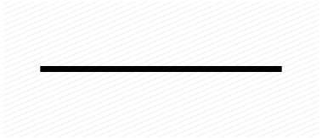 | wire | Changing the number of cells  - The greater the number of cells there are …  the brighter the bulb, the louder the buzzer, the faster the motor.  - The fewer the cells there are …  the dimmer the bulb, the quieter the buzzer, the slower the motor.
circuit | A path through which electricity flows, usually beginning and ending at a battery |  | wire
circuit diagram | A simple representation of an electric circuit using symbols | 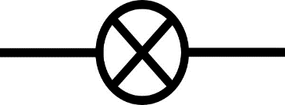 | bulb | Changing the number of components  - The greater the number of bulbs, the dimmer they will be.  - The fewer the bulbs, the brighter they will be.
complete circuit | An electric circuit with no gaps, allowing the current to flow |  | bulb
incomplete circuit | An electric circuit with a gap, preventing the flow of current | 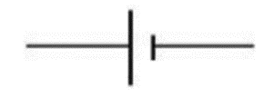 | battery made of one cell | Changing the length of wire  - The shorter the wire …  the brighter the bulb, the louder the buzzer, the faster the motor.  - The longer the wire …  the dimmer the bulb, the quieter the buzzer, the slower the motor.
voltage | The force that ‘pushes’ current through a wire |  | battery made of one cell
volts (V) | Unit of measurement of voltage | 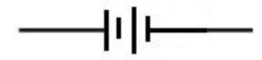 | battery made of two cells
current | The flow of electricity |  | battery made of two cells | TYPES OF SWITCHES
amps (A) | Unit of measurement of current | 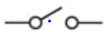  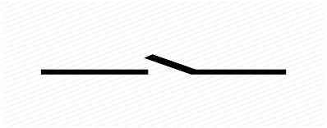  or | switch | 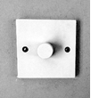 dimmer  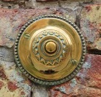 push  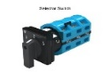selector  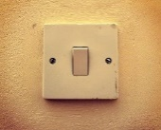 toggle  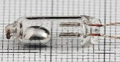 tilt
series circuit | A simple electric circuit where one component follows another |  | switch
buzzer | A component of a circuit that converts electrical energy to sound energy | 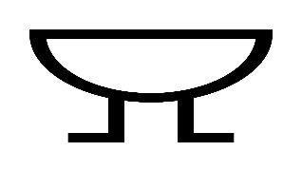 | buzzer
motor | A component of a circuit that converts electrical energy to moving energy |  | buzzer
resistance | A force that opposes (‘pushes against’) the movement of electricity | 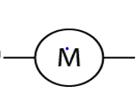 | motor

