The Ancient Greeks – Knowledge Organiser Year 6 Summer 1
Timeline

146 BC
Rome conquers Greece
332 BC
Alexander conquers Egypt
432 BC
The Parthenon is completed in Athens
342 BC
Aristotle begins to tutor Alexander the Great
508 BC
Democracy is introduced in Athens
800 BC
750 BC
Homer write The Iliad and The Odyssey
Vocabulary |  | Greek Philosophers |  | The 12 Olympian Gods
Conquer | To overcome or gain control by force. | Ancient Greek philosophy arose in the 6th century BC. Philosophy made sense of the world in a non-religious way. It covered a variety of subjects. |  | Zeus | King of all Gods
Conquer | To overcome or gain control by force. |  |  | Artemis | Moon Goddess
Polytheistic | Religious system where people believe in or worship more than one god. | Plato | Philosopher and student of Socrates : best known for writing ‘Republic’. | Hera | Queen of the Gods
Colony | A settlement which is under the control of your home country. | Homer | Legendary author famous for writing the Iliad & Odyssey | Poseidon | God of the sea
pentathlon | A sporting contest with 5 specific events. | Archimedes | Scientist & mathematician: famous for reportedly yelling ‘Eureka!’ after realising the link between volume, density & displacement. | Hestia | Goddess of the hearth
morphology | The shape or form of something. | Aristotle | His theory of biology was the first systematic observation and collection of data; categorizing living animals by carrying out dissections. | Aphrodite | Goddess of love
philosopher | Someone who studies the nature of life, truth and knowledge. | Pythagoras | Philosopher & mathematician most known for his rules of triangles | Ares | God of war
City-State | A self-governing state made up of a city and surrounding territory. | Map of Ancient Greece |  | Demeter | Goddess of plants
patron | a person who gives financial or other support to a person. | 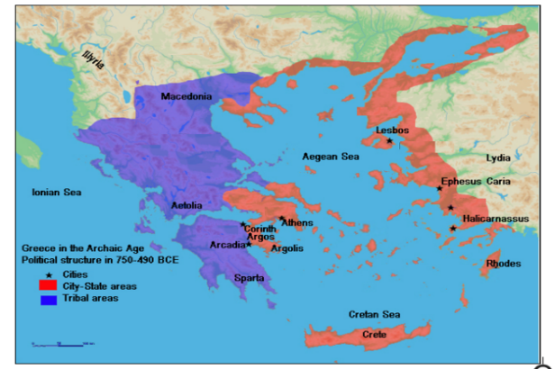 |  | Apollo | Sun God
Olympics | Sporting event and sacrifice held every four years in honour of Zeus. |  |  | Athena | Goddess of  wisdom and war
dissolution | When a form of leadership comes to an end. |  |  | Hermes | Messenger of the Gods
Scholar | A person who through deep study has gained mastery in subjects. |  |  | Hephaestus | God of blacksmiths

