Year 6 RE Knowledge Organiser Spring Term Two: Does it matter what we believe about Creation?
VOCABULARY |  | 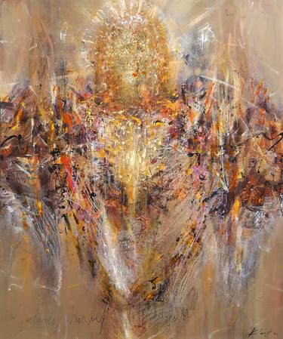  Christians believe that God created the world and that Creation is detailed in the book of Genesis in the Bible.  This can be seen as controversial as it goes against the scientific theories of The Big Bang and Evolution (living things today evolved from earlier types.)  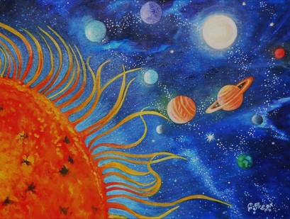  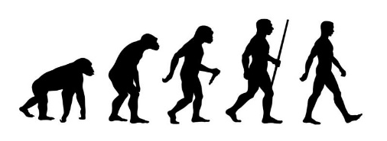  However, there are and have been many Christian scientists. They read Genesis as a poetic account rather than a scientific document.  In this unit we  consider how humans are always searching for answers and will have many opportunities to pose and try to answer questions about the meaning and purpose of life.
Creation | The action or process of bringing something into existence
Belief | An acceptance that something exists or is true, especially one without proof.
Believer | Someone who believes in God, a religion or a set of beliefs which do not have to be of a religious nature.
Genesis | The first book of the Bible. Its name derives from the opening words: “In the beginning…."
Atheist | A person who does not believe in God.
Science | Knowledge about the world that is based on facts learned through experiments and observations
God | (In Christianity) The one who created and rules over all the world.
Agnostic | Someone who is open-minded to the existence of God or gods but has doubt for their existence.
Big Bang Theory | A common theory of the beginning of the Universe and evolution of living things.
Monotheistic | A belief in one God.
Evolution | The theory that all the kinds of living things that exist today developed from earlier types.
Universe | The whole of space and everything in it.

