LIGHT – Knowledge Organiser Year 6 Spring 2

Vocabulary |  | Properties of Light | Refraction & Spectrum of Light
light | A type of energy. It stimulates our eye to send signals to the brain so that we can see. | - Light appears to travel in straight lines.  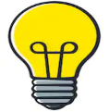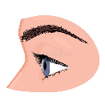  - Light travels very fast!  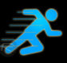 300,000,000 metres per second!  - When blocked, it creates a 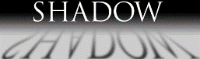 | White light can be refracted through a prism to split it into its different colours (spectrum):  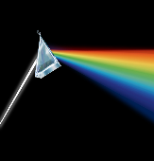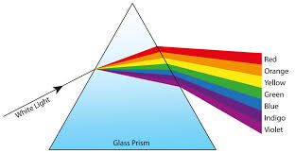  The spectrum of white light is RED, ORANGE, YELLOW, GREEN, BLUE, INDIGO and VIOLET.
light source | The origin of light (where light comes from). Can be natural or artificial.
ray | The straight path with which light travels.
reflect | When light bounces off an object without being absorbed. [Noun = reflection].
refract | When light changes direction as it passes through one material into another.  [noun = refraction]. |  | Shadows
refract |  | How We See | Shadows have the same shape as the objects that cast them.  Shadows change length and direction during the day.  Shadows change in size depending on the distance between the object and light source. | 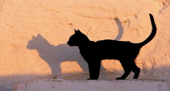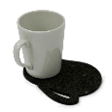  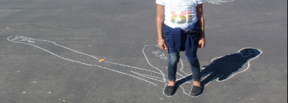  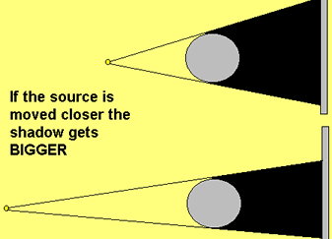
emit | To produce and give off/out a type of energy (eg light or sound). | We can see objects because they give out light or reflect light into our eyes.  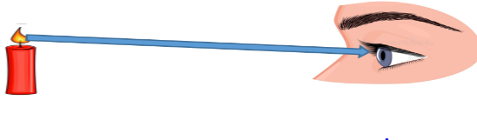  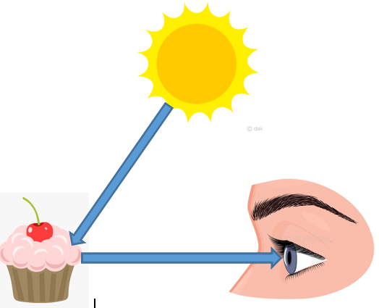
transparent | Allows all light to pass through.
translucent | Allows some light to pass through. Objects on the other side of a translucent object cannot be seen clearly.
opaque | Does not allow any light to pass through.
periscope | A piece of equipment using two mirrors set at 45°. It enables us to view objects which would be out of sight.
spectrum | A range of colours produced by separating out white light (as seen in a rainbow).  Red, Orange, Yellow, Green, Blue, Indigo, Violet

