Global Trade – Knowledge Organiser Year 6 Spring 2
How important is trade to the United Kingdom?
In this unit, the children find out about how goods and services are traded around the world. They will explore the UK's trade links today and in the past, finding out about goods imported and exported and the methods of transport used. Pupils will learn about the benefits of trading internationally, as well as the risks to this area. They will also learn about Fairtrade and why it is important in a global market.
Vocabulary |  | 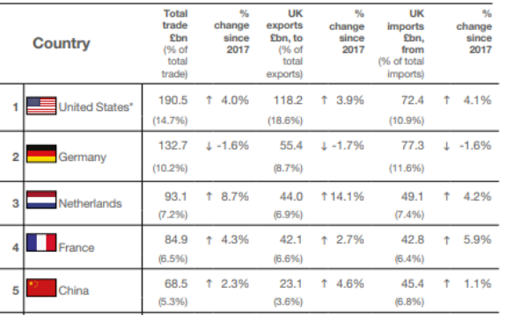 |  |  | UK Exports
Trade | Buying and selling goods and services. |  |  |  | 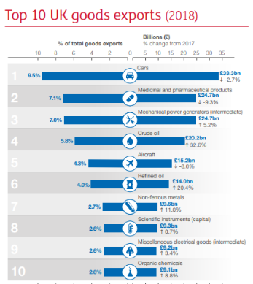  The UK’s top 10 exports in the year 2018.  Cars being the number one export.
Import | Buying goods or services into a country from abroad.
Export | Selling goods or services to another country.
Product | Something that is made and then sold. |  |  | The UKs top 5 trading partners.
Fairtrade | Buying and selling goods for a fair price. |  |  | The UKs top 5 trading partners.
Goods | Things that are bought and transported. |  |  | The Fairtrade symbol that can be seen on packaging in the UK and designates that the trader has been given a fair price for his product.
Trading partners | Countries that have agreed to trade with each other.
Consumable | Something that you can eat or drink
Consumer | A person who buys goods or services for their own use
Consumer | A person who buys goods or services for their own use | Where does our food come from? | The silk and spice routes from Europe to the Middle-East and Asia
Producers | A person, company, or country that makes, grows, or supplies goods or products for sale. | 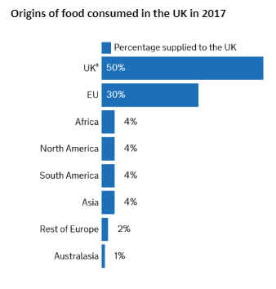 | 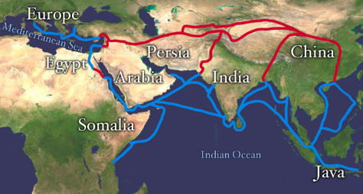
Purchase power | The ability to buy products and services.
Equality | When everyone is treated the same, especially in status, rights, or opportunities

