CLASSIFICATION – Knowledge Organiser Year 6 Spring 1
Vocabulary |  | Classification of Living Things
classification | Sorting things into sets or classes which have  features in common. | 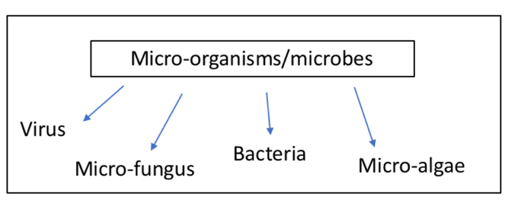  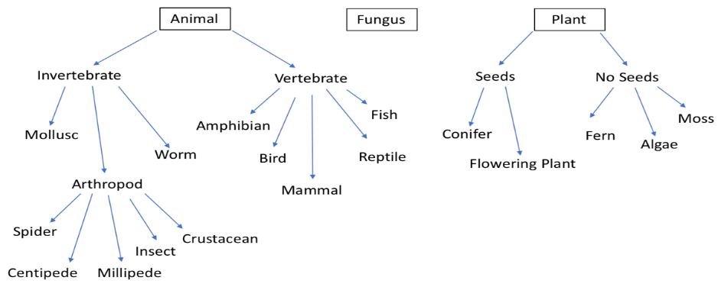
subdivide | To classify into smaller and smaller groups.
organism | An individual living thing.
cells | Tiny living ‘building blocks’ that make up all living things.
Kingdom | The largest groups into which living things can be  classified.
Fungus/fungi | A living thing which gets its nutrients from other organisms. Fungi are not plants or animals but belong to their own kingdom.
micro-organism  /microbe | A very small living thing which can only be seen  using a microscope. Examples include: bacteria,  viruses and many fungi.
arthropod | An invertebrate with a jointed exoskeleton. Can be  subdivided into: insects, spiders (arachnids),  crustaceans, centipedes and millipedes. | An Example of a Classification Key | The 7 life processes of living thing
insect | Arthropod with 6 legs, 3 parts to the body (head,  thorax and abdomen), antennae and often has  wings. E.g. bee, butterfly, beetle, ant. | 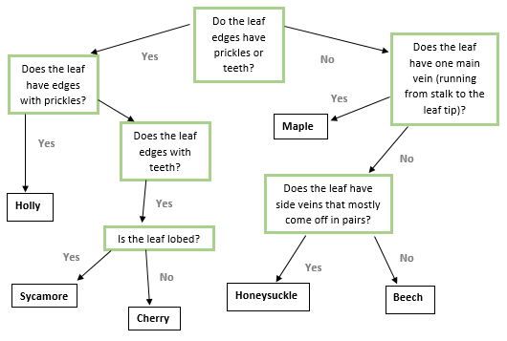 | To classify something as living it must  display seven life processes. This can  be remembered using the following  acronym:  MRS NERG  Movement – ability to move  Reproduction – make a copy of itself  Sensitivity – sense their surroundings  Nutrition – get or make food  Excretion – get rid of waste materials  Respiration – get energy from food  Growth – grow and develop
spider (arachnid) | Arthropod with 8 legs and 2 parts to the body (head  and abdomen). E.g. tarantula, scorpion, tick, mite.
crustacean | Arthropod with 10 or more legs and gills to breathe  in water. E.g. crab, prawn, lobster, woodlouse.
centipede | Arthropod with a segmented body and one pair of  legs per segment. All are carnivores.
millipede | Arthropod with a segmented body and two pairs of  legs per segment. All are herbivores.
worm | Soft-bodied invertebrate with a long, slender,  limbless body. Moves by crawling or burrowing.
mollusc | Soft-bodied invertebrate which mostly live in  water. Sometimes have a shell. Include snails, slugs,  octopuses, squid and clams.

