Knowledge Organiser Year 6 Spring 1 – The Old Testament - Freedom
Vocabulary |  | Background learning/research/consideration: | The Ten Commandments
 |  | - The story of Moses is from 1400BC. At that time, the Israelites were the Egyptians’ slaves. Following a lengthy struggle, Moses led the Israelites to freedom.  - God then presented Moses and the Israelites with The Ten Commandments and explained that if they followed these rules, they would be saved forever.  - Christians believe that by following God’s commandments they will achieve freedom and justice for themselves and others. They try to do so by helping those in need, such as through charitable organisations like Christian Aid or the Salvation Army.  - Atheists do not believe in God, but many of The Ten Commandments can be followed by anyone, regardless of who or what they believe in. | The Ten Commandments
The Old Testament | The first part of the Christian holy book, the Bible, and believed to be the word of God. |  | Christians believe God gave humans guidelines for living to keep them close to him. These guidelines are called The Ten Commandments.  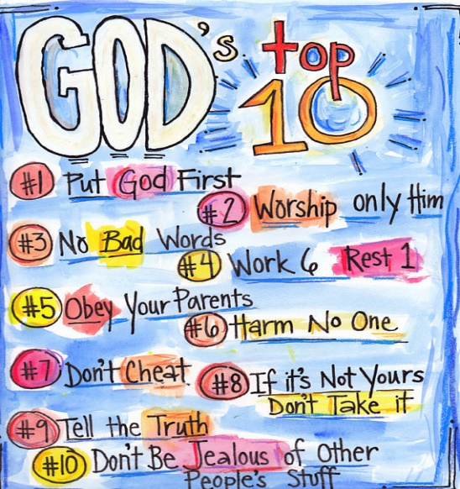  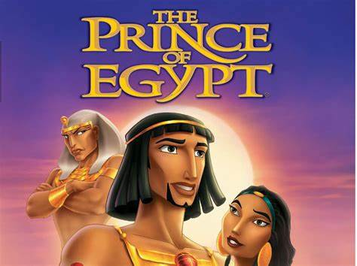  Moses’ story is told through the Prince of Egypt.
The Israelites  Plague | Members of the Hebrew nation referred to in the Old Testament.  An infestation or invasion. In the book of Exodus, the ten plagues were disasters inflicted on Egypt by God.
Pharaoh | The leader in Ancient Egypt.
Enslavement | The state of being a slave.
Moses | Was born in Egypt and led the Israelites away from slavery.
Exodus | The part of the bible which explains how the Israelites were led from Egypt. Also means a mass departure of people.
Covenant | An agreement or pact.
The Ten  Commandments | The guidelines for living which Christians try to follow. Christians believe they were revealed to Moses on Mount Sinai.
Atheist | A person who does not believe in God or a higher power.
Salvation | Being saved from harm. In Christianity, it refers to being saved from sin and its consequences.

