Benin 900-1300AD – Knowledge Organiser Year 5 Spring 1
Timeline
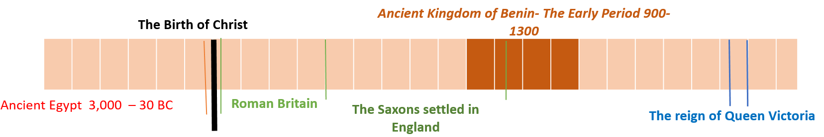
Vocabulary |  | 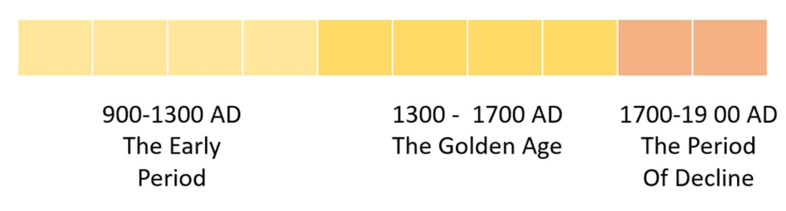 |  | Important Information
empire | A number of individual nations that are all controlled by the government or ruler of one particular country. |  |  | The ancient kingdom of Benin began as a small group of villages who joined together to improve trading and security.
dynasty | A line of people from the same family who play an important role. |  |  | The Kingdom of Benin rose to become a powerful empire in the 16th and 17th centuries.
Edo | The name of the group of people who lived within the ancient kingdom of Benin. |  |  | Large moats and walls were built around the outside of the kingdom in order to protect it.
Igodomigodo | The name for the original land of the Kingdom of Benin. Late became known as Edo and then Benin City. |  |  | The first dynasty of kings were called Ogisos. This dynasty ended in 1180AD.
Ogiso | The Edo word meaning “king of the sky”. |  |  | The second dynasty of kings were called Obas.
Oba | The Yoruba word for “king”. | Important People |  | Kings in ancient Benin were treated like Gods.
Ife | A city near the kingdom of Benin, ruled by the Yoruba people. | Ogiso Igodo | The first king of Benin. | In the 15th century, European sailors began to sail to Africa.
Yoruba | The name of the group of people who lived in the city of Ife. | Ogiso Owodo | The last of the Ogiso kings. | The Obas held a lot of power, including being in charge of law and justice, controlling trade and taxation, and commanding the army.
kingdom | A place ruled by a king or queen. | Ekaladerhan | . The son of Ogiso Owodo who was banished to Ife and became its king. | The Edo people believed that their first kings were descended from Osanobua, a god who came down from the sky to create the world.
oracle | A person who was believed to pass on advice from Gods to ordinary people. | Prince Oranmiyan | . A son of Ekaladerhan who was sent to rule over the people of Benin. | The region developed an advanced artistic culture during its Golden Age, especially with its famous artefacts of bronze, iron and ivory.
trade | The exchanging of goods. | Oba Eweka | The first of the dynasty of kings known as the Obas. Son of Prince Oranmiyan | In 1897AD, British troops destroyed Benin City and took Benin under its control.
barter | To exchange goods or services for other goods or services without using money. | Oba Ewedo | King from 1260 until 1274 who built a fine new palace in Benin City during his reign. | Benin City is the location of the ancient kingdom of Benin. This is situated in Nigeria. The ancient kingdom of Benin is not located in the modern country of Benin which is a different country in Africa.
guild | A group of craftsmen or merchants who often had considerable power. | Oba Ewuare | King from 1440 until 1473.Expanded and protected the kingdom greatly and set up trading links. | There are very few written sources of evidence about Ancient Benin. Storytellers were very important and kept the kingdom’s history alive by telling stories aloud every evening.

