EVOLUTION and INHERITANCE – Knowledge Organiser Year 6 Autumn 2
Vocabulary |  | Mary Anning (1799 – 1847) | Charles Darwin (1809 – 1882)
evolve | To gradually change and develop over time. | 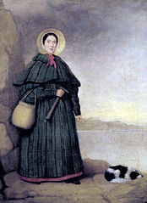  Mary Anning was a famous palaeontologist and fossil collector who lived in Dorset, England. Her family was poor, so she used to go fossil hunting in the cliffs where  they lived and sold the fossils to make a living. Over time, Mary became an expert  at finding fossils in the Jurassic cliffs along the coastline.  During her lifetime, Mary found and identified many pre-  historic fossils including the first complete Ichthyosaurus  skeleton (an ancient fish-shaped reptile), a long-necked marine reptile called a Plesiosaurus and the first pterosaur fossil, a flying reptile. These fossils were important evidence to suggest that such prehistoric creatures existed but also that they could become extinct.  Anning’s discoveries contributed to important changes in  the scientific thinking about prehistoric life and how the  world has changed over time. | Charles Darwin was an English scientist/naturalist who is famous for developing the Theory of Evolution by Natural Selection. He believed that all life on Earth evolved from a common ancestor whose offspring varied slightly from the previous generation.  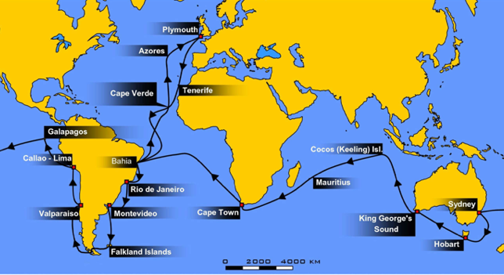  In 1831, Charles Darwin boarded a Royal Navy ship (H.M.S. Beagle) and began a five-year voyage around the world collecting samples of plants, animals and rocks from the various locations he visited.  During the voyage, Darwin visited the Galapagos Islands  and discovered several species of finches (small birds)  which varied from island to island. This discovery and  analysis of the samples he collected on his voyage helped  him to develop the Theory of Evolution.  Darwin suggested that living things changed over time by  Natural Selection: a natural process in which the  animals and plants best suited to their environment will  survive and reproduce and those less suited will be weaker  and die out.  In 1859, Darwin published his ideas in a book, ‘On the Origin of Species’.  “A man who dares to waste one hour of time has not discovered the value of life.”  Charles Darwin
characteristic | A quality or feature of a person or thing which makes them recognisable.
feature | An observable characteristic e.g., eye colour, nose  shape.
offspring | A child or young of a living thing.
reproduction | The process of producing offspring from a parent.
generation | The period of time between the birth of parents and the birth of their children.
species | A group of living things which have the same main  characteristics and can reproduce with each other.
population | A group of animals or plants of the same species living in the same environment.
variation | A change or slight difference in something.
inherit | When an offspring receives characteristics from its parent.
adaptation | A characteristic of a living thing which increases its chances of survival. | Darwin’s Theory of Evolution by Natural Selection  - All living things are born with slight variations or differences.  - Some differences help with survival – we say that these living things are better adapted.  - Many species have lots of babies, some of which will not survive.  - Those that do survive are better adapted to living and breeding in that environment.  - Adaptations that increase chances of survival are passed down through generations and become more common in the population, eventually leading to evolution.
environment | The place in which something lives.
survival of the  fittest | Where animals and plants which are best suited to changes in their environment have an advantage in surviving over those which are less well suited.
natural selection | A process in which animals and plants best suited to their environment will survive and reproduce and those less suited will be weaker and die out.
compete | To try to obtain something that others also need  in order to survive.
extinct | No longer exists.
fossils | The remains or traces of animals or plants from a long time ago found inside a rock.
fossil record | The evidence provided by fossils in layers of rocks  showing the sequence of evolution through time.

