What is Africa like? – Knowledge Organiser Year 6 Autumn 2
 |  | Map showing the different time zones of Africa. |  | Natural Resources found in Africa
Africa is a more diverse place than is stereotypically perceived. There is great variation in terrain, climate and natural resources. |  | 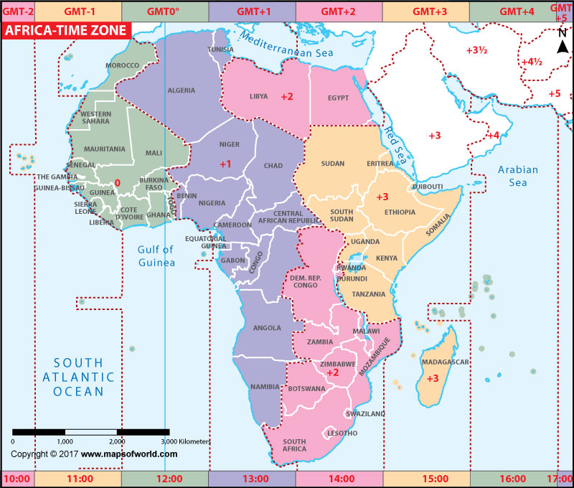 |  | - Gas and oil  - Copper and iron ore  - Uranium  - Gold and diamonds
Vocabulary |  |  |  | Map of Africa
diverse | If a group or range of things is diverse, it is made up of a wide variety of things. |  |  | 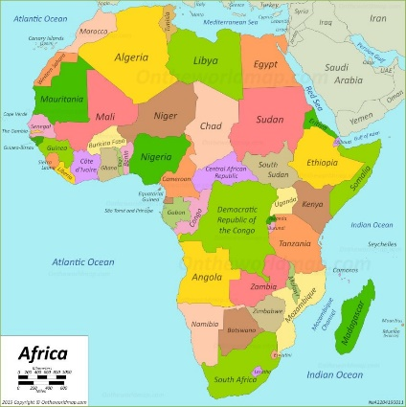  Key Mountain:  Kilimanjaro (5,895m high)  Kay Waterfall:  Victoria Falls (Zambia)  Key Desert:  Sahara (The largest in the world)  Key Oceans / Seas:  Atlantic Ocean, Indian Ocean, Mediterranean Sea, Red Sea  Key City:  Cairo, Egypt (population of 15.6 million people)
stereotype | A stereotype is a fixed set of characteristics that a lot of people believe represent a particular type of person or thing.
natural resources | Resources that exist or occur in nature and are not made or caused by people (e.g. wind, water, oil, metals).
GMT  Greenwich Mean Time | The standard time in Great Britain which is used to calculate the time in the rest of the world. | Climate | Terrain
perception | Your perception of something is the way that you think about it or the impression you have of it. | 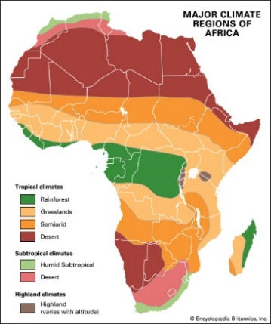 | Africa has eight main physical regions:  - the Sahara,  - the Sahel,  - the Ethiopian Highlands,  - the savanna,  - the Swahili Coast,  - the rain forest,  - the African Great Lakes  - Southern Africa.  Some of these regions cover large areas of the continent while others are remote areas. Each of these regions has unique animal and plant communities.
time zone | Time zones give specific areas on the Earth a time of day that is earlier or later than neighbouring time zones.
savannah | Open grasslands, usually with scattered bushes or trees
semi-arid | Characterized by little rainfall and scrubby vegetation
production | The process of making or growing something in large amounts.
vegetation | Plants, trees, and flowers
plateau | A large area of high and fairly flat land.

