CIRCULATORY SYSTEM and HEALTHY LIFESTYLES – Knowledge Organiser Year 6 Autumn 1
Vocabulary |  | Effect of lifestyle on the health of the body | Circulatory System
function | A job or role. | The lifestyle choices we make can have an impact  on the health of our body, some choices have a  positive effect whereas others have a negative  effect.  - Exercise increases the heart rate as more  oxygen must be pumped to the muscles to help  to release energy.  - Exercise increases fitness (building stamina and strengthening muscles).  - A balanced diet improves health by providing the right amount of each nutrient group whilst cutting down on harmful food groups (e.g. fats which clog arteries and veins, preventing efficient blood flow).  - Drugs can be beneficial (e.g. prescribed medicines) or harmful (e.g. alcohol, tobacco  and heroine).  - Some drugs are addictive.  - Medicinal drugs can be harmful if misused. | 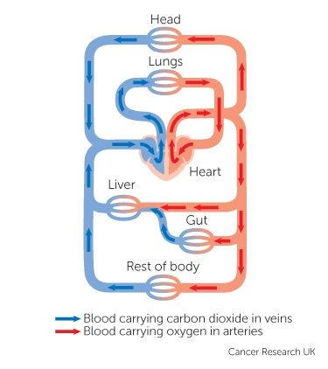  - Blood is pumped from the heart to the lungs to collect oxygen.  - Blood is transported back to the heart.  - Blood is pumped around the body in arteries, carrying oxygen and dissolved nutrients.  - Some blood passes by the small intestine (gut) where it collects more dissolved nutrients.  - After depositing oxygen around the body (particularly at the muscles), blood returns to the heart in veins.  - Blood is pumped to the lungs once again to collect oxygen and to breathe out carbon dioxide … and the cycle continues.
organ | A part of the body that has a particular function or set  of functions.
heart | Organ made up of a special muscle that beats. Pumps  blood around the body. Protected by the rib cage.
blood | A liquid carried by blood vessels around the body, has  many functions including transport of gases and  nutrients.
blood vessels | A tube through which blood is transported around the  body.
artery | A blood vessel that carries blood away from the heart.
vein | A blood vessel that carries blood back to the heart.
circulate | To continually move around.
circulatory  system | The system that transports blood through the body.  Consists of the heart and the blood vessels.
oxygen | A gas that we breathe in through the lungs. Carried by  blood all around the body where it is needed to produce  energy (especially in the muscles).
carbon dioxide | A waste gas produced when the body generates energy.  Carried by blood to the lungs where it is breathed out.
oxygenated | To be full of oxygen. | William Harvey (1578 – 1657)
deoxygenated | To have had all the oxygen removed. | 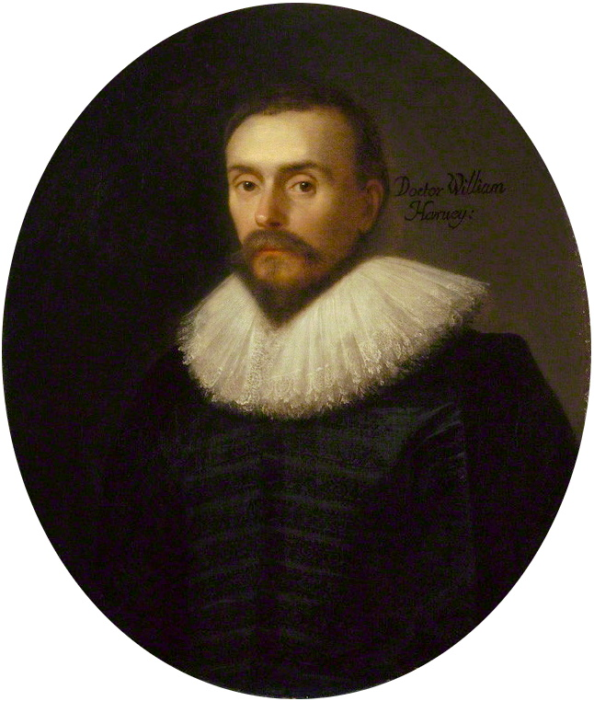  A scientist and doctor who first  discovered and described,  through experiments, the  human circulatory system and  the role of the heart in pumping  blood around the body.  Famous quote: “All we know is still infinitely  less than all that remains unknown.”
lungs | Organs that control the gases entering and leaving the  body when we breathe. Protected by the rib cage.
pulse | The regular movements felt in the walls of an artery caused by the beating of the heart.
nutrients | Chemicals obtained from food that are beneficial to (good for) the body. Each nutrient has a particular function or set of functions to keep the body healthy.
drugs | Chemicals that can have either harmful or beneficial  effects on the body.

