Year 6 Knowledge Organiser: What is important to Muslims?
VOCABULARY |  | The Qur’an and prayer beads.  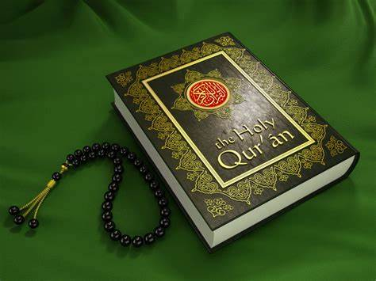  Wuzu area and prayer mat.  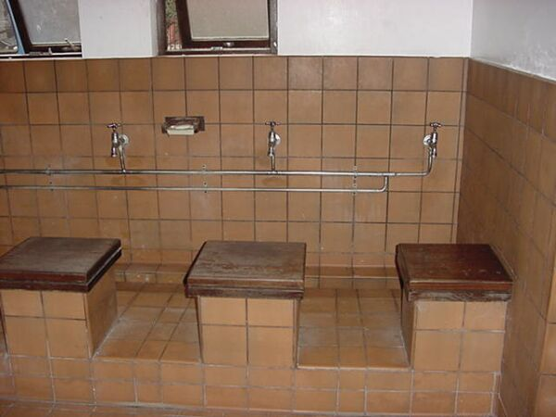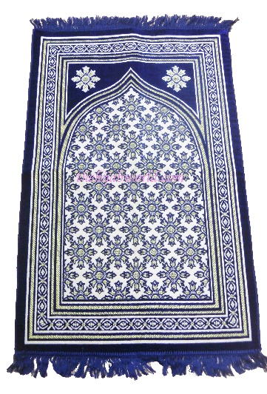  The Kaaba at Mecca  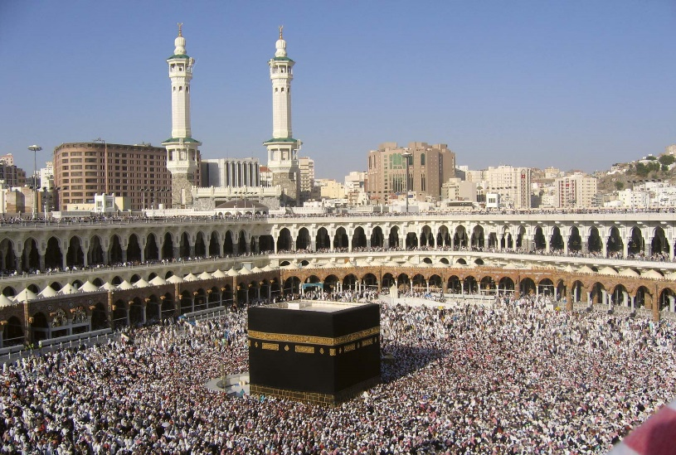
Islam | The religion of Muslims.
Muslim | A follower of the religion of Islam.
Five Pillars | The five obligations that every Muslim must satisfy in order to live a good and responsible life.
Foundations | Underlying basis or principle.
Arabic | A language of the Arabs, spoken by some 150 million people throughout the Middle East and North Africa. The Qur’an was first revealed in Arabic
Qur’an | The sacred text of Islam.
Mosque | A Muslim place of worship.
Allah | God in Arabic.
Muhammad (PBUH – Peace Be Upon Him) | Prophet (messenger) and founder of Islam.
Shahadah | Pillar 1 - The belief in Allah and Muhammad as his messenger.
Monotheistic | The belief that there is only one God.
Prophet | In religion, a prophet is said to be in contact with a divine being.
Salah | Pillar 2 – Prayer
Mecca | The birthplace of Muhammad (PBUH) in Saudi Arabia.
Kaaba | A cubed in the court of the Great Mosque at Mecca.
Wudu | The act of washing certain body parts before prayer.
Zakat | Pillar 3 – Charity of 2.5% of wealth which Muslims should pay.
Sawm | Pillar 4 - The Arabic word for fasting.
Ramadan | The holy ninth month of the Islamic calendar, during which time Muslims refrain from eating or drinking during sunrise.
Eid-el-Fitr | A festival which marks the end of the month long period of Ramadan.
Hajj | Pillar 5 - A pilgrimage which takes place annually to the holy city of Mecca; Muslims try to carry out at least once in their lifetime.
Pilgrimage | A journey made to a sacred place or a religious journey.
Ismail | Regarded as a prophet in Islam and an ancestor of Muhammad. He helped his father build the Kaaba.
Hagar | Wife of the prophet Abraham. She gave birth to his first son Ismail
Surah | A verse in the Qur’an.
Islamophobia | Dislike or prejudice against Muslims or Islam.

